Automatic report for a Completely Randomized Design (CRD)
International Potato Center
December 17, 2020
Table of Contents

1. Model specification and data description
Data from 85 genotypes have been evaluated using a completely randomized design. The statistical model is
$$y_{ij}=μ+τ_{i}+ϵ_{ij}$$
where
- $y_{ij}$ is the observed response with genotype $i$ and replication $j$.
- $μ$ is the mean response over all genotypes and replications.
- $τ_{i}$ is the effect for genotype $i$.
- $ϵ_{ij}$ is the error term.
In this model we assume that the errors are independent and have a normal distribution with common variance, that is, $ϵ_{ij}∼N(0,σ_{ϵ}^{2})$.

2. Analysis for trait trw

2.1. Exploratory analysis
It is always good to have some visualization of your data. Below a histogram and a boxplot are shown.
par(mfrow = c(1, 2))
hist(mydata$trait)
boxplot(mydata$trait)
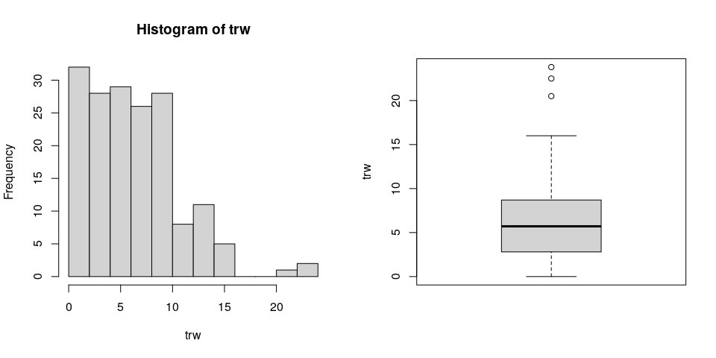

2.2. ANOVA
You have fitted a linear model for a CRD. The ANOVA table for your model is:
model <- aov(trait ~ treatment, data = mydata)
# Anova table
at <- anova(model)
at
Analysis of Variance Table
Response: "trw"
Df Sum Sq Mean Sq F value Pr(>F)
geno 84 1962.2 23.360 1.4066 0.05932 .
Residuals 85 1411.6 16.608
---
Signif. codes: 0 '***' 0.001 '**' 0.01 '*' 0.05 '.' 0.1 ' ' 1
The coefficient of variation for this experiment is 65.39%. The p-value for genotypes is 0.05932 which is not significant at the 5% level.

2.3. Assumptions
Don’t forget the assumptions of the model. It is supposed that the errors are independent with a normal distribution and with the same variance for all the genotypes. The following residuals plots can help you evaluate this:
par(mfrow = c(1, 2))
plot(model, which = 1)
plot(model, which = 2)
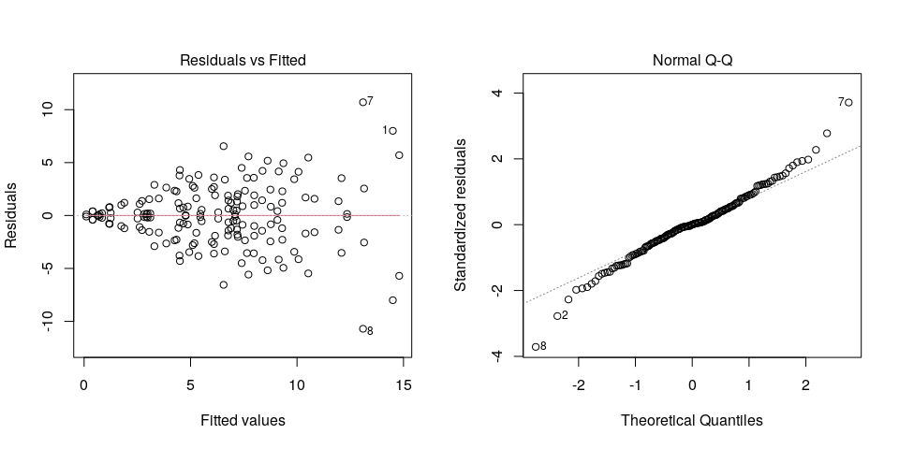
Any trend in the residuals in the left plot would violate the assumption of independence while a trend in the variability of the residuals –for instance a funnel shape– suggests heterogeneity of variances. Deviation from the theoretical normal line on the right plot is a sign of lack of normality.

2.4. Genotype means
Because the effect of genotypes was not significant in the ANOVA, multiple comparison tests are not presented. The means of your genotypes are:
tapply(mydata$trait, mydata$treatment, mean, na.rm = TRUE)
Beauregard Blesbok Brondal Cemsa Huambachero INA-100
14.500 4.430 6.610 13.100 6.900 1.745
Jewel Jonathan Kemb-27 Mohc Naveto Necsu1560
3.860 0.400 6.760 0.400 0.100 6.100
Ningshu1 PJ05.012 PJ05.018 PJ05.052 PJ05.064 PJ05.091
7.970 6.550 7.990 12.090 3.510 14.800
PJ05.108 PJ05.109 PJ05.114 PJ05.120 PJ05.124 PJ05.130
9.140 3.060 7.010 5.270 13.150 7.400
PJ05.171 PJ05.172 PJ05.180 PJ05.212 PJ05.213 PJ05.217
6.150 2.720 4.660 10.530 4.500 2.930
PJ05.219 PJ05.220 PJ05.224 PJ05.227 PJ05.233 PJ05.235
7.440 3.300 3.110 8.380 12.350 7.720
PJ05.236 PJ05.238 PJ05.239 PJ05.240 PJ05.243 PJ05.245
8.620 7.555 10.820 7.200 9.360 5.100
PJ05.247 PJ05.248 PJ05.251 PJ05.253 PJ05.254 PJ05.257
0.670 4.480 7.160 8.360 5.520 11.950
PJ05.258 PJ05.302 PJ05.303 PJ05.304 PJ05.306 PJ05.324
6.100 5.180 9.870 1.250 6.000 4.940
PJ05.347 PZ06.011 PZ06.026 PZ06.027 PZ06.048 PZ06.053
7.090 4.500 4.340 2.980 9.080 8.750
PZ06.062 PZ06.070 PZ06.072 PZ06.091 PZ06.099 PZ06.103
1.890 0.730 9.310 7.220 10.400 8.770
PZ06.115 PZ06.120 PZ06.124 PZ06.196 PZ06.235 PZ06.304
2.840 6.780 1.175 0.840 7.990 2.610
PZ06.348 PZ06.349 PZ06.353 PZ06.359 PZ06.385 PZ06.441
7.180 9.300 6.780 4.870 5.460 4.250
Resisto Santo_Amaro Tanzania Xushu18 Yanshu1 Yurimaguas
7.650 6.300 1.200 5.370 10.070 2.510
Zapallo
4.770

2.5. Variance components
Below are the variance components for this model, under the assumption that genotypes are random. Here the model is fitted using REML.
model <- lme4::lmer(trait ~ (1|treatment), data = mydata)
vc <- data.frame(lme4::VarCorr(model))
vc[, c(1, 4, 5)]
Variance Std.Dev.
geno 3.376055 1.837404
Residual 16.607569 4.075239

3. Analysis for trait vw

3.1. Exploratory analysis
It is always good to have some visualization of your data. Below a histogram and a boxplot are shown.
par(mfrow = c(1, 2))
hist(mydata$trait)
boxplot(mydata$trait)
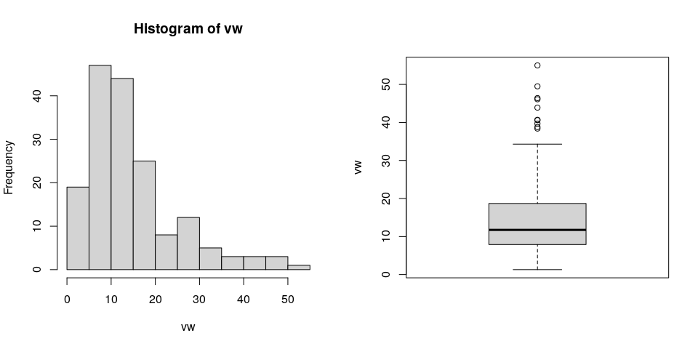

3.2. ANOVA
You have fitted a linear model for a CRD. The ANOVA table for your model is:
model <- aov(trait ~ treatment, data = mydata)
# Anova table
at <- anova(model)
at
Analysis of Variance Table
Response: "vw"
Df Sum Sq Mean Sq F value Pr(>F)
geno 84 13610.1 162.024 2.8087 1.756e-06 ***
Residuals 85 4903.4 57.687
---
Signif. codes: 0 '***' 0.001 '**' 0.01 '*' 0.05 '.' 0.1 ' ' 1
The coefficient of variation for this experiment is 51.24%. The p-value for genotypes is 1.756e-06 which is significant at the 5% level.

3.3. Assumptions
Don’t forget the assumptions of the model. It is supposed that the errors are independent with a normal distribution and with the same variance for all the genotypes. The following residuals plots can help you evaluate this:
par(mfrow = c(1, 2))
plot(model, which = 1)
plot(model, which = 2)
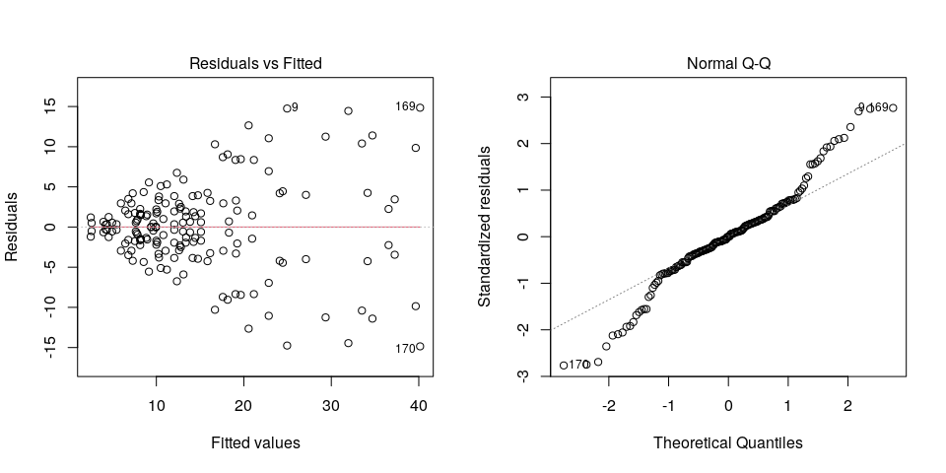
Any trend in the residuals in the left plot would violate the assumption of independence while a trend in the variability of the residuals –for instance a funnel shape– suggests heterogeneity of variances. Deviation from the theoretical normal line on the right plot is a sign of lack of normality.

3.4. Genotype means
Below are the sorted means for each genotype using the Fisher’s Least Significant Difference method and the multiple comparisons method of Tukey, both at the 5% level. Letters indicate if there are significant differences

3.3.1. LSD test
agricolae::LSD.test(mydata$trait, mydata$treatment, at[2, 1], at[2, 3])$groups
means groups
Zapallo 40.15 a
Xushu18 39.65 ab
Tanzania 37.25 abc
PZ06.124 36.55 abc
PZ06.011 34.70 abcd
INA-100 34.15 abcde
Jonathan 33.50 abcdef
Naveto 31.95 abcdefg
Cemsa 29.35 abcdefgh
PZ06.072 27.10 abcdefghi
Huambachero 24.95 bcdefghij
PZ06.196 24.45 cdefghijk
Santo_Amaro 24.10 cdefghijkl
Jewel 22.85 cdefghijklm
PJ05.257 22.85 cdefghijklm
Necsu1560 21.15 defghijklmn
PZ06.304 20.95 defghijklmno
PJ05.108 20.55 defghijklmno
Mohc 19.65 defghijklmnop
PJ05.235 19.25 efghijklmnopq
PZ06.062 19.10 efghijklmnopq
PZ06.026 19.05 fghijklmnopq
PZ06.027 18.30 ghijklmnopqr
Kemb-27 18.15 ghijklmnopqr
PZ06.115 17.65 ghijklmnopqrs
PJ05.120 17.60 ghijklmnopqrs
Beauregard 16.70 hijklmnopqrst
Brondal 16.15 hijklmnopqrst
PJ05.224 15.85 hijklmnopqrst
PZ06.120 15.10 hijklmnopqrst
PZ06.235 15.10 hijklmnopqrst
PZ06.359 14.75 hijklmnopqrst
Resisto 14.45 hijklmnopqrst
PZ06.353 14.25 ijklmnopqrst
PZ06.099 14.15 ijklmnopqrst
PZ06.385 13.85 ijklmnopqrst
PJ05.258 13.40 ijklmnopqrst
PJ05.254 13.35 ijklmnopqrst
Yanshu1 13.10 ijklmnopqrst
PJ05.251 13.05 ijklmnopqrst
PZ06.070 12.80 ijklmnopqrst
PJ05.109 12.70 ijklmnopqrst
Blesbok 12.60 ijklmnopqrst
PJ05.212 12.35 ijklmnopqrst
PJ05.213 12.05 ijklmnopqrst
PZ06.349 12.05 ijklmnopqrst
PZ06.441 12.05 ijklmnopqrst
PJ05.247 11.20 jklmnopqrst
PJ05.130 11.05 jklmnopqrst
PJ05.227 10.80 jklmnopqrst
PJ05.217 10.50 jklmnopqrst
Ningshu1 10.30 jklmnopqrst
PJ05.012 10.25 jklmnopqrst
PJ05.091 10.10 jklmnopqrst
PJ05.172 10.00 jklmnopqrst
PJ05.324 10.00 jklmnopqrst
PJ05.253 9.95 jklmnopqrst
PZ06.053 9.65 klmnopqrst
PZ06.091 9.40 klmnopqrst
PJ05.248 9.15 lmnopqrst
PJ05.240 8.95 mnopqrst
PZ06.103 8.85 mnopqrst
PJ05.052 8.55 mnopqrst
PJ05.219 8.20 mnopqrst
PJ05.304 8.20 mnopqrst
PJ05.238 8.15 mnopqrst
PZ06.048 8.15 mnopqrst
PJ05.124 7.85 mnopqrst
PJ05.347 7.75 nopqrst
PJ05.114 7.65 nopqrst
PZ06.348 7.55 nopqrst
Yurimaguas 7.30 nopqrst
PJ05.243 7.15 nopqrst
PJ05.236 6.80 nopqrst
PJ05.245 6.80 nopqrst
PJ05.180 6.45 nopqrst
PJ05.220 5.95 opqrst
PJ05.233 5.45 pqrst
PJ05.171 4.95 pqrst
PJ05.303 4.55 qrst
PJ05.018 4.35 qrst
PJ05.239 4.20 qrst
PJ05.302 3.95 rst
PJ05.306 2.60 st
PJ05.064 2.50 t

3.3.2. Tukey test
agricolae::HSD.test(mydata$trait, mydata$treatment, at[2, 1], at[2, 3])$groups
means groups
Zapallo 40.15 a
Xushu18 39.65 ab
Tanzania 37.25 abc
PZ06.124 36.55 abc
PZ06.011 34.70 abcd
INA-100 34.15 abcd
Jonathan 33.50 abcd
Naveto 31.95 abcd
Cemsa 29.35 abcd
PZ06.072 27.10 abcd
Huambachero 24.95 abcd
PZ06.196 24.45 abcd
Santo_Amaro 24.10 abcd
Jewel 22.85 abcd
PJ05.257 22.85 abcd
Necsu1560 21.15 abcd
PZ06.304 20.95 abcd
PJ05.108 20.55 abcd
Mohc 19.65 abcd
PJ05.235 19.25 abcd
PZ06.062 19.10 abcd
PZ06.026 19.05 abcd
PZ06.027 18.30 abcd
Kemb-27 18.15 abcd
PZ06.115 17.65 abcd
PJ05.120 17.60 abcd
Beauregard 16.70 abcd
Brondal 16.15 abcd
PJ05.224 15.85 abcd
PZ06.120 15.10 abcd
PZ06.235 15.10 abcd
PZ06.359 14.75 abcd
Resisto 14.45 abcd
PZ06.353 14.25 abcd
PZ06.099 14.15 abcd
PZ06.385 13.85 abcd
PJ05.258 13.40 abcd
PJ05.254 13.35 abcd
Yanshu1 13.10 abcd
PJ05.251 13.05 abcd
PZ06.070 12.80 abcd
PJ05.109 12.70 abcd
Blesbok 12.60 abcd
PJ05.212 12.35 abcd
PJ05.213 12.05 abcd
PZ06.349 12.05 abcd
PZ06.441 12.05 abcd
PJ05.247 11.20 abcd
PJ05.130 11.05 abcd
PJ05.227 10.80 abcd
PJ05.217 10.50 abcd
Ningshu1 10.30 abcd
PJ05.012 10.25 abcd
PJ05.091 10.10 abcd
PJ05.172 10.00 abcd
PJ05.324 10.00 abcd
PJ05.253 9.95 abcd
PZ06.053 9.65 abcd
PZ06.091 9.40 abcd
PJ05.248 9.15 abcd
PJ05.240 8.95 abcd
PZ06.103 8.85 abcd
PJ05.052 8.55 abcd
PJ05.219 8.20 abcd
PJ05.304 8.20 abcd
PJ05.238 8.15 abcd
PZ06.048 8.15 abcd
PJ05.124 7.85 abcd
PJ05.347 7.75 abcd
PJ05.114 7.65 abcd
PZ06.348 7.55 abcd
Yurimaguas 7.30 abcd
PJ05.243 7.15 abcd
PJ05.236 6.80 abcd
PJ05.245 6.80 abcd
PJ05.180 6.45 bcd
PJ05.220 5.95 cd
PJ05.233 5.45 cd
PJ05.171 4.95 cd
PJ05.303 4.55 cd
PJ05.018 4.35 cd
PJ05.239 4.20 cd
PJ05.302 3.95 cd
PJ05.306 2.60 d
PJ05.064 2.50 d

3.5. Variance components
Below are the variance components for this model, under the assumption that genotypes are random. Here the model is fitted using REML.
model <- lme4::lmer(trait ~ (1|treatment), data = mydata)
vc <- data.frame(lme4::VarCorr(model))
vc[, c(1, 4, 5)]
Variance Std.Dev.
geno 52.16888 7.222803
Residual 57.68671 7.595176

